FGM/C in Kenya: Progress, But Concerns Remain
Prof. Samuel Kimani,^{i} Shannon Thomson,^{ii} Sean Callaghan,^{iii} Melanie Rattue^{iv}
^{i} University of Nairobi, Africa Coordinating Centre for the Abandonment of FGM/C
^{ii} Research Manager, Orchid Project
^{iii} Head of Research, Orchid Project
^{iv} Statistician, Orchid Project

E-mail: research@orchidproject.org
Abstract
The national prevalence of female genital mutilation/cutting (‘FGM/C’) in Kenya reduced from 37.6% of women aged 15–49 in 1998 to 14.8% in 2022. Despite this progress, concerns remain about medicalisation of the practice, changes in the type of cutting and cross-border FGM/C. There is evidence of a trend towards hiding FGM/C by medicalising it, and families in urban areas with higher levels of education are opting for cutting by medical professionals. The prevalence of FGM/C in which some flesh is taken has reduced more noticeably than the prevalence of the most severe type (infibulation). Cross-border FGM/C is a concern, particularly migrants moving into and out of Kenya to be cut. Ethnicity and social identity are the primary drivers, and this has created geographic hotspots where prevalence is well above the national average (between 57% and 87%). To address these concerns, programming must consider ethnic and religious drivers and engage with medical professionals to reduce the likelihood of medicalised FGM/C. In addition, estalibishing a regional coordinating body to address cross-border FGM/C is critical.
Keywords: female genital mutilation/cutting, FGM, FGC, Kenya, medicalisation, cross-border, Type 3

1. Context Analysis
Female genital mutilation/cutting (‘FGM/C’) includes all procedures that involve partial or total removal of the external female genitalia, or other injury to the female genital organs for non-medical reasons. The practice has no health benefits for girls or women and can cause severe bleeding, problems urinating, cysts, infections, and complications in childbirth, and increases the risk of newborn death. More than 200 million women and girls are estimated to have undergone FGM/C globally, and approximately 4.2 million girls are at risk annually. FGM/C is practised in countries all over the world, primarily in Africa, Asia and the Middle East.
1.1 Changes in Prevalence
According to the series of Kenya Demographic and Health Surveys (the ‘KDHS’) spanning 1998–2022, the prevalence of FGM/C among women aged 15–49 in Kenya dropped from 37.6% (1998) to 14.8% (2022) (see Figure 1).
Declines in prevalence over the last decade can be seen in both urban and rural populations and across the surveyed age cohorts (women aged between 15 and 49). The prevalence among rural-dwelling women in 2014 was 25.9%, declining to 18.4% by 2022. Among urban-dwelling women, the prevalence in 2014 was 13.8%, and by 2022 it had reduced to 9.7%.
Education is still an important determinant of FGM/C prevalence. The practice is most common among women with no formal educations (56.3%, compared to 5.9% of women with secondary or higher educations).
FGM/C prevalence also correlates with economic status. There is a prevalence of 32.0% among women in the lowest wealth quintile, compared to 6.6% among those in the highest wealth quintile.
Prevalence is especially decreasing among women aged 15–19, which may be the result of effective FGM/C programming within the younger generations. Prevalence in this group reduced from 26% in 1998 to 9.1% in 2022.
FGM/C in Kenya is closely linked to ethnic identity; therefore, the practice varies widely between groups. FGM/C is most common in Kenya among the Kisii (70.9%), Maasai (56.7%), Somali (86.9%), and Samburu (75.9%), although it is less commonly practised by other ethnic groups.
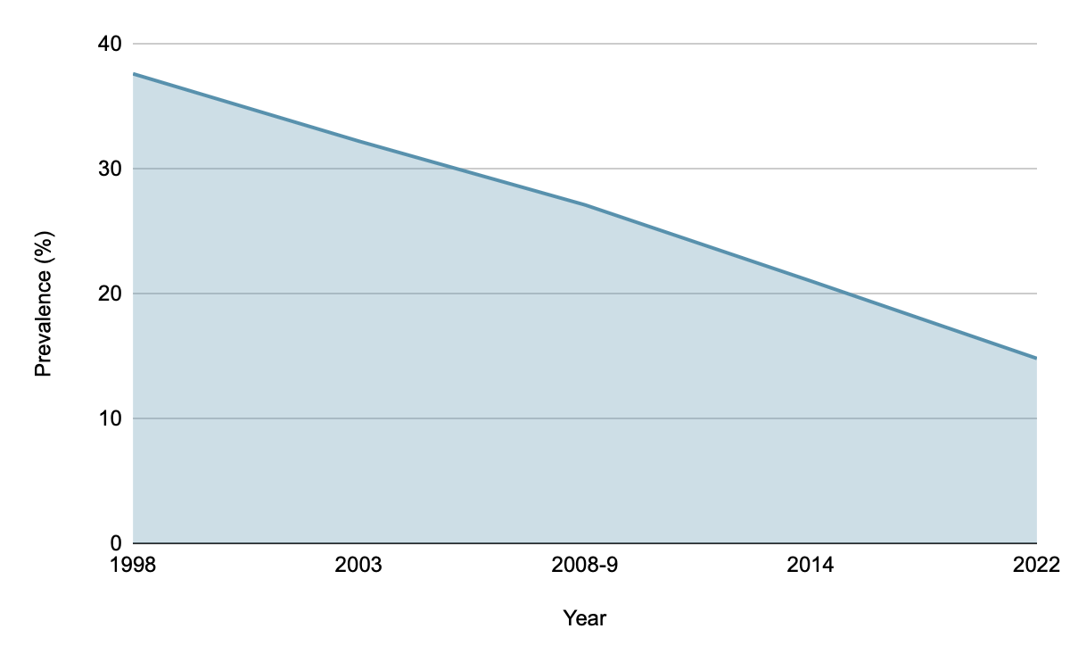
The Kenyan population was estimated to be 56.8 million in early 2023, an increase from 46.7 million in 2014 and 30.2 million in 1998. This means that, currently, an estimated 4.2 million women and girls have been affected by FGM/C, compared to 4.9 million in 2014 and 5.7 million in 1998. While the absolute number of women and girls affected by FGM/C is decreasing, the decline is not uniform across the country. In the North Eastern region, which includes Mandera, Garissa and Wajir counties, the absolute number of women and girls affected by FGM/C doubled between 1998 and 2022 as population growth outstripped any percentage gains.
Figure 1: Change in FGM/C prevalence in Kenya
between 1998 and 2022 (in women aged 15–49)
1.2 Politico-Legal Environment
The Prohibition of Female Genital Mutilation Act, 2011 (the ‘FGM/C Act’) came into effect on 4 October 2011 and is the principal legislation addressing FGM/C in Kenya. It is a national law that criminalises all forms of FGM/C, regardless of the age or status of the affected girl or woman.
The FGM/C Act is a comprehensive piece of legislation that established the Anti-Female Genital Mutilation Board and defined offences and punishments related to FGM/C in Kenya. Article 2 of the act clearly defines FGM/C as
all procedures involving partial or total removal of the female genitalia or other injury to the female genital organs, or any harmful procedure to the female genitalia, for non-medical reasons . . . .
It includes (a) clitoridectomy; (b) excision; and (c) infibulation (with accompanying definitions of each). The only exceptions are a ‘sexual reassignment procedure or a medical procedure that has a genuine therapeutic purpose’. The law does not, however, define the meaning of ‘therapeutic’ in this context, potentially leaving a window for abuse by unscrupulous health professionals who are willing to perform FGM/C disguised as genital modifications/ cosmetic surgeries.
The following Kenyan legislation also addresses FGM/C:
- The Children Act 2022 states, ‘No person shall subject a child to— (a) in the case of a male child, forced circumcision; (b) female genital mutilation; (c) child marriage; (d) virginity testing; (e) girl child beading; (f) except with the advice of a medical geneticist, organ change or removal in case of an intersex child; or (g) any other cultural or religious rite, custom or practice that is likely to negatively affect the child’s life, health, social wellbeing, dignity, physical, emotional or psychological development.’
- The Protection Against Domestic Violence Act (2015), under Article 3(a)(ii), defines ‘domestic violence’ as including ‘female genital mutilation’. Article 19(1)(g) provides the facility to set up protection orders covering potential victims against engagement, or threats to engage, ‘in cultural or customary rites or practices that abuse the protected person’.
- Finally, Article 4 of Kenya’s Penal Code (revised 2014) outlaws the deliberate infliction of ‘grievous harm’, which includes ‘any permanent or serious injury to any external or internal organ, membrane or sense’.
In 2019, during the ICPD 25+, President Kenyatta committed by decree to ending FGM/C by 2022 and to addressing FGM/C in government instruments. This commitment was supported by an action plan developed by the Ministry of Public Service and Gender together with the UN Joint Programme on the Elimination of FGM/C. The action plan is known as the Presidential Costed Action Plan to End FGM in Kenya by 2022.
President William Ruto has continued to espouse abandoning FGM/C through political statements, support for FGM/C programmes, increased budgetary allocation to the Anti-FGM Board and policy directives through the Ministry of Public Service and Gender.
The following Kenyan policies address FGM/C:
- the National Policy for the Eradication of Female Genital Mutilation (2019);
- the National Adolescent Sexual Reproductive Health Policy (2015); and
- the School Health Policy (2018).
Despite the robust Kenyan politico-legal environment, the system was tested in 2017 when a petition was filed against the FGM/C Act by a medical professional, who claimed that it was unconstitutional. In 2021, the High Court in Nairobi upheld and validated the law as constitutional. One of the presiding judges, Justice Achode, said,
The Constitution grants the freedom for one to exercise their culture. However, that freedom has to be carried out in line with other constitutional provisions. From the law, we observe that culture entails various modes of expression, and therefore what is limited is any expression that will cause harm to a person or by a person to another person. FGM/C falls into the latter category.
2. Progress, But Concerns Remain
The progress toward ending FGM/C in Kenya is encouraging. Overall, the incidence of the practice is decreasing. However, there are aspects in Kenya that remain concerning. These include the medicalisation of the practice (in other words, FGM/C performed by healthcare workers), changes in the type of cutting performed (‘less severe’ types of FGM/C and the cutting of younger girls), hotspots where the practice continues, and cross-border FGM/C.
2.1 Medicalised FGM/C
In Kenya, 16.9% of women aged 15–49 and 15.9% of girls aged 10–14 report having been cut by a health professional. That places Kenya in the top five countries for cases of medicalised FGM/C (Egypt – 38%, Sudan – 67%, Guinea – 15%, and Nigeria – 13%). The prevalence of medicalised FGM/C among women aged 15–49 has dropped from 19.7% in 2008/2009, and that has been attributed to awareness-raising campaigns among health professionals.
Shell-Duncan et al. note, from the Demographic and Health Survey data, that Kenyan girls who were cut before the age of 15 are more likely than their mothers to have been cut by a medical professional. Medicalisation is linked to less severe forms of cutting and to lower ages of cutting. It is also more common among specific ethnic groups in Kenya, which include the Somali and Kisii.
A study by Kimani et al. among the Abagusii and Somali in 2020 found that urban families tended to practise less severe forms of cutting and were more likely to pursue medicalised FGM/C. This common trend has typically been attributed to higher levels of education and inter-cultural marriage as a result of urbanisation and migration.
Kimani et al. also found that some health professionals who conduct FGM/C refer to it as ‘genital modification’ to categorise it as a form of plastic surgery. The authors of the study argue that efforts to hide the practice are increasing.
Christoffersen-Deb’s study in 2005, also among the Abagusii, found that adolescent girls were opting for medicalised FGM/C as a way of negotiating with family members who were insisting on them being cut.
2.2 Uneven Progress
In 2014, 1.6% of women aged 15–49 who had undergone FGM/C reported having been cut without any flesh removed, 87.2% experienced having flesh removed, 9.3% reported being ‘sewn closed’ (infibulated) and 1.9% did not know what kind of cut they had experienced.
In 2022, the proportion of women who had undergone FGM/C who reported being cut without any flesh removed increased dramatically to 11.9%. The proportion who experienced having flesh removed decreased to 70.1%. The proportion who reported being ‘sewn closed’ increased to 11.6%. The proportion who did not know what kind of cut they experienced also increased to 6.5%.
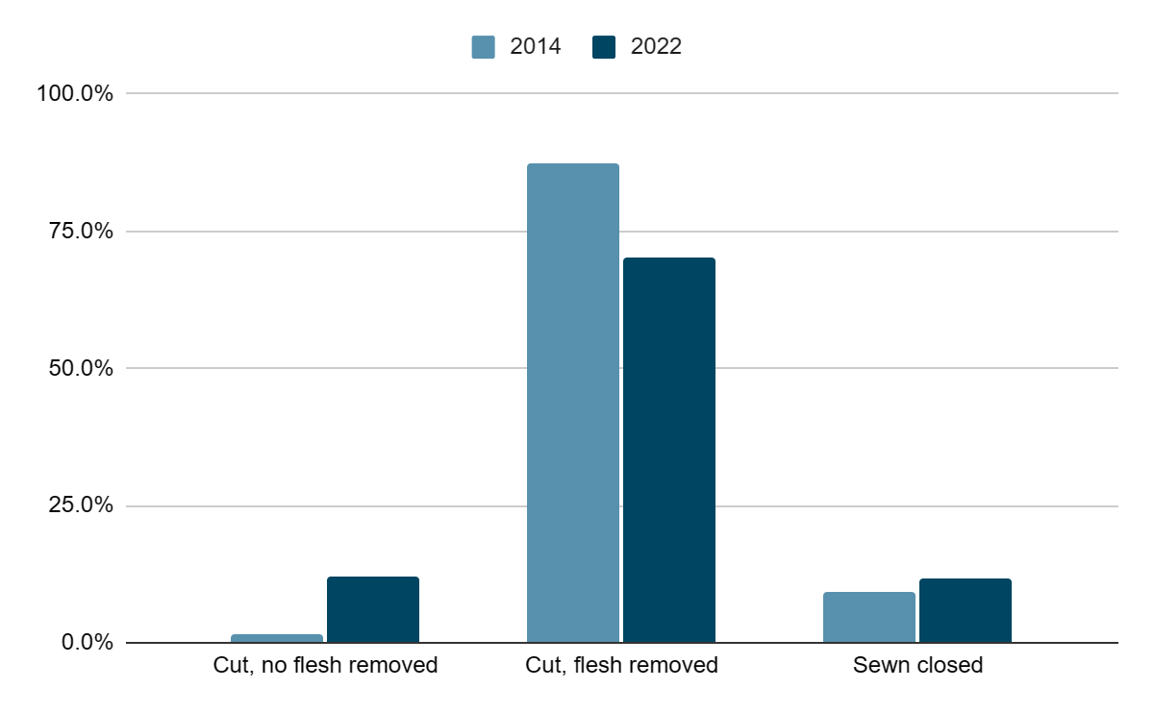
Figure 2: Estimated number of Kenyan women and
girls impacted by FGM/C, according to type of cut
When taking the number of women and girls impacted by FGM/C into account, it is clear that this apparent increase in the proportion of women reporting being ‘sewn closed’ is more a reflection of much sharper changes in the numbers of women experiencing other forms of FGM/C (see Figure 2). Not all ethnic groups in Kenya practise Type 3 FGM/C, or infibulation (being ‘sewn closed’); approximately one-third of those who practise this type of cutting are Somali.
2.3 FGM/C Hotspots
Although FGM/C prevalence is dropping nationally, there are geographic hotspots where prevalence soars above the national rate. In the 2022 KDHS, prevalence among the following ethnic groups was reported to be between 57% and 87%: Somali (86.9%), Kisii (70.3%), Maasai (56.7%) and Samburu (75.9%). Sample sizes for some ethnic groups were small, but consdiering prevalence according to each ethnic group is critical to addressing the unique needs of different communities and to prioritising resources.
2.4 Cross-Border FGM/C
A baseline study conducted by UNICEF in 2017 found that communities along the Uganda, Ethiopia, Somalia and Tanzania borders may be engaged in cross-border FGM/C, particularly members of the Pokot, Rendille, Somali and Maasai ethnic groups, in preparation for early marriages.
Girls are most often brought from or taken to countries surrounding Kenya to undergo FGM/C, especially Tanzania. In some cases, traditional cutters are taken from Kenya to surrounding countries to perform FGM/C there.
Certain studies demonstrate that some families travel out of Kenya to avoid prosecution as a result of the stringent enforcement of the law. In other cases, girls are brought to Kenya to have FGM/C conducted by medical professionals who are deemed to have more experience performing the procedure.
Key factors that contribute to cross-border FGM/C include:
- shared traditions, especially child/early marriage;
- fear of arrest in native country and feeling that there is limited prosecution in neighbouring countries;
- lack of proximity to traditional cutters in native country;
- quality and affordability of FGM/C services in a neighbouring country; and
- absence of strong regional monitoring mechanisms for reporting.
Porous borders that lack surveillance, a lack of cross-border legislation in neighbouring countries and the lack of a joint coordinating mechanism are some of the primary reasons that cross-border FGM/C continues.

3. Understanding Drivers
The baseline study conducted by UNICEF in 2017 concluded that ethnicity is a decisive factor in FGM/C prevalence. Drivers such as marriageability and the belief that FGM/C ensures personal hygiene were found to be reducing, and this was attributed to increased awareness and education. However, drivers related to social acceptance seem to be increasingly important to women and girls themselves – or at least to a majority.
FGM/C is still seen by some Somali women in Kenya to be a religious requirement – 32% of Somali women aged 15–49 believe it to be so. The UNICEF study was conducted in only two locations – Balambala and Habaswein – but marks a clear difference from the results of the KDHS of 2014, which found that 82.3% of Somali women in Kenya believe FGM/C to be a religious requirement.
The Population Council documented a religiously orientated approach that was taken among the Somali community in Wajir county, Kenya in 2007. Regional scholars were drawn together from four districts of the North Eastern region to discuss a justification for de-linking FGM/C from Islam. The scholars who participated recommended a slow approach to educating communities and separating FGM/C from Islam. Many suggested using harm-reduction strategies such as promoting less severe forms of cutting, and some raised concerns that local religious leaders are not comfortable discussing FGM/C in public spaces.
4. What Does This Mean for FGM/C in Kenya?
Overall, progress is being made towards reducing FGM/C in Kenya.
There is political will and government support in the form of legislation, a coordinating body and budget allocations.
Prevalence reduced from 37.6% to 14.8% (of women aged 15–49) between 1998 and 2022, and among women aged 15–19 prevalence reduced from 26.0% in 1998 to 9.1% in 2022.
Programming, political will and continued advocacy appear to have played parts in reducing the overall prevalence, but concerns remain about the incidence of medicalised FGM/C, changes in the types of cutting performed and cross-border FGM/C.
While there has been progress made in reducing the incidence of cutting during which flesh is taken, the types of FGM/C that are ‘most severe’ (infibulation) and ‘least severe’ (nicking/cutting without taking flesh) are not reducing at the same rate.
There is evidence to suggest that the politico-legal environment in the country has driven Kenyans towards medicalised FGM/C, which is characterised by less severe types of cutting and a changing of the language to avoid referring to cutting as ‘FGM/C’. However, policy interventions are associated with under-reporting of FGM/C due to fear of prosecution – the so-called ‘social desirability bias’ affecting the accuracy of data on FGM/C.
Prevalence varies widely across Kenya. FGM/C is practised to varying degrees by many ethnic groups. There are five ethnic groups that do not practise it: the Luo, Luhya, Turkana, Pokomo and Teso. Social acceptance and ethnic identity are critical drivers of the practice; for some ethnic groups, a belief that FGM/C is required by their religion suffices.
To reduce prevalence in the hotspots, programming and advocacy will need to adapt and respond to the social and religious drivers in different groups.
Cross-border coordination mechanisms will be critical to reducing the practice across porous borders.
Further work with health professionals to deter medicalised cutting will also be necessary.
The collection of nuanced data that provides insights into regional and ethnic differences will be critical to directing programming where it is most needed.

References

Samburu county prevalence, as Samburu ethnic data was unavailable in the publicly available dataset.
50% of 56.8m (population in 2023) is 28.4m women and girls. 14.8% FGM/C prevalence means approx. 4.2m women and girls affected.
50% of 46.7m (population in 2014) is 23.35m women and girls. 21% FGM/C prevalence means approx. 4.9m women and girls affected.
50% of 30.2m (population in 1998) is 15.1m women and girls. 37.6% FGM/C prevalence means approx. 5.7m women and girls affected.
In 2014, 9.3% of 4.9m women reported being ‘sewn closed’, which equals 456,000; in 2022, 11.6% of 4.2m women reported being ‘sewn closed’, which equals 487,000.
World Health Organization (2023) FGM Factsheet. Available at https://www.who.int/news-room/fact-sheets/detail/female-genital-mutilation.
(‘KDHS 1998’): National Council for Population and Development – NCPD/Kenya, Central Bureau of Statistics – CBS/Kenya, and Macro International (1999) Kenya Demographic and Health Survey 1998, p.168. Calverton, Maryland, USA: NDPD, CBS, and Macro International. Available at https://dhsprogram.com/publications/publication-FR102-DHS-Final-Reports.cfm.
(‘KDHS 2022’): KNBS and ICF (2023) Kenya Demographic and Health Survey 2022: Key Indicators Report, p.93. Nairobi, Kenya, and Rockville, Maryland, USA: KNBS and ICF. Available at https://dhsprogram.com/publications/publication-PR143-Preliminary-Reports-Key-Indicators-Reports.cfm.
- (‘KDHS 2014’): Kenya National Bureau of Statistics, Ministry of Health/Kenya, National AIDS Control Council/Kenya, Kenya Medical Research Institute, National Council for Population and Development/Kenya, and ICF International (2015) Kenya Demographic and Health Survey 2014, p.333. Rockville, MD, USA: Kenya National Bureau of Statistics, Ministry of Health/Kenya, National AIDS Control Council/Kenya, Kenya Medical Research Institute, National Council for Population and Development/Kenya, and ICF International. Available at https://dhsprogram.com/publications/publication-FR308-DHS-Final-Reports.cfm. - KDHS 2022, p.93.
Orchid Project’s analysis of the original KDHS 2022 dataset, supplied by STATcompiler.
Worldometer (2023) Kenya Population (Live). Available at https://www.worldometers.info/world-population/kenya-population/.
Republic of Kenya (2022) The Children Act. National Council for Law Reporting, with the Authority of the Attorney-General. Available at http://kenyalaw.org:8181/exist/rest//db/kenyalex/Kenya/Legislation/English/ Acts%20and%20Regulations/C/Children%20Act%20-%20No.%2029%20of%202022/docs/ChildrenAct29of2022.pdf.
Republic of Kenya (2015) Protection Against Domestic Violence Act. Available at http://kenyalaw.org/kl/fileadmin/pdfdownloads/Acts/ProtectionAgainstDomesticViolenceAct_2015.pdf.
Republic of Kenya (2014) The Penal Code Act. National Council for Law Reporting, with the Authority of the Attorney-General. Available at http://kenyalaw.org:8181/exist/rest//db/kenyalex/Kenya/Legislation/English/Acts%20and% 20Regulations/P/Penal%20Code%20Act%20-%20No.%2010%20of%201930/docs/PenalCodeAct10of1930.pdf.
Nita Bhalla (2019) ‘Kenya pledges to end FGM by 2022 – ahead of global target’, Reuters, 12 November. Available at https://www.reuters.com/article/us-kenya-women-fgm-trfn-idUSKBN1XM2GN.
Selina Teyie (2022) ‘Kenya on the right track to ending FGM’, The Star Kenya, 6 October. Available at https://www.the-star.co.ke/news/2022-10-06-kenya-on-the-right-path-to-ending-fgm-unfpa/.
Equality Now (2021) Kenya’s High Court Rules Anti-FGM Law Is Constitutional: A Jubilant Day For Girls And Women In Kenya, 17 March. Available at https://www.equalitynow.org/press_release/kenya_fgm_case_response_2021/.
Ibid.
Ibid.
KDHS 2022, p.646.
UNICEF (2021) The Medicalization of FGM in Kenya, Somalia, Ethiopia and Eritrea. Available at https://www.unicef.org/esa/media/8866/file/TheMedicalization-of-FGM-2021.pdf.
Kenya National Bureau of Statistics – KNBS – and ICF Macro (2010) Kenya Demographic and Health Survey 2008–09, p.267. Calverton, Maryland: KNBS and ICF Macro. Available at https://dhsprogram.com/publications/publication-FR229-DHS-Final-Reports.cfm.
UNICEF (2021), op. cit.
Ibid.
Ibid.
Ibid.
Samuel Kimani, Caroline W. Kabiru, Jacinta Muteshi, and Jaldesa Guyo (2020) 'Female genital mutilation/cutting: Emerging factors sustaining medicalization related changes in selected Kenyan communities’, PLOS One. Available at https://doi.org/10.1371/journal.pone.0228410.
Ibid.
Ibid.
Astrid Christoffersen-Deb (2005) ‘Taming tradition: Medicalized Female Genital Practices in Western Kenya’, Medical Anthropology Quarterly 19(4), pp.402–418. Available at https://pubmed.ncbi.nlm.nih.gov/16435647/.
KDHS 2014, p.333.
KDHS 2022, p.93.
Orchid Project’s analysis of the original KDHS 2022 dataset, supplied by STATcompiler.
United Nations Children’s Fund (UNICEF) (2017) Baseline Study Report: Female Genital Mutilation/ Cutting and Child Marriage among the Rendille, Maasai, Pokot, Samburu and Somali Communities in Kenya. Nairobi: UNICEF. Available at https://www.unicef.org/kenya/media/541/file/Kenya-0000076.pdf.pdf.
Ibid.
- UNFPA (2019) Beyond the crossing: Female Genital Mutilation Across Borders, Ethiopia, Kenya, Somalia, Tanzania and Uganda. - Building Bridges to End FGM (2019) Cross-Border FGM. Available at https://copfgm.org/cross-border-fgm.
United Nations Children’s Fund (UNICEF) (2017) Baseline Study Report: Female Genital Mutilation/ Cutting and Child Marriage among the Rendille, Maasai, Pokot, Samburu and Somali Communities in Kenya. Nairobi: UNICEF. Available at https://www.unicef.org/kenya/media/541/file/Kenya-0000076.pdf.pdf.
Ibid.
Ibid.
Ibid.
Ibid.
Ibid.
KDHS 2014, p.340.
Maryam Sheikh Abdi and Ian Askew (2009) A Religious Oriented Approach to Addressing FGM/C among the Somali Community of Wajir, Kenya. Population Council FRONTIERS Report. Available at https://knowledgecommons.popcouncil.org/departments_sbsr-rh/1173/.
Ibid.
Ibid.

